# Lab 6

# Write LCD Functions and Test the LCD

Write lcd18f.h and lcd18f.c files to add the LCD functions needed.

Write a test program called LCDtest.c to test all the functions of the lcd18f.c code in a creative way. At some point during the test your first name must be clearly displayed on the first line and your last name at the start of the second. Use must use a protection resistor in for each pin. Upload a picture of your wiring and commented code in a doc or pdf. Also upload a demo video to D2L.

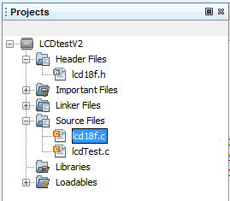

Write the code in lcd18f.c to match the wiring in the following schematic:

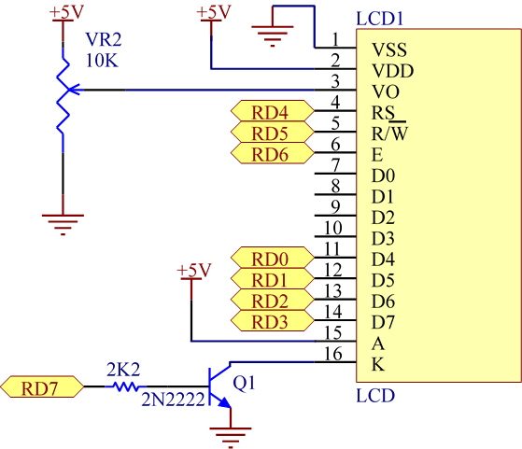

**CODE SECTIONS**

**“lcd18f.h”**

/********************************************************************************

* lcd18f.h

* ECET165 Embedded Micro-controllers

* Created: 13 Feb 2023

* Aaron Huinink

* Provides functionality for pic18f micro-controllers to connect to an lcd on

* port d.

********************************************************************************/

#ifndef LCD18F_H

#define LCD18F_H

#ifdef __cplusplus

extern "C" {

#endif

#include <xc.h>

#define LCD_PORT PORTD

#define LCD_LAT LATD

#define LCD_TRIS TRISD

#define LCD_ANSEL ANSELD

#define LCD_WPU WPUD

#define LCD_K LATDbits.LATD7

#define LCD_EN LATDbits.LATD6

#define LCD_RW LATDbits.LATD5

#define LCD_RS LATDbits.LATD4

#define LCD_BF PORTDbits.RD3

#define LCD_STROBE LCD_EN = 1; __delay_us(1); LCD_EN = 0

#define LCD_PORTEN LCD_ANSEL = 0x0; LCD_TRIS = 0x0; LCD_WPU = 0xFF; LCD_K = 1; __delay_us(1)

#define LCD_CLEAR LCDinstruct(0x01)

#define LCD_HOME LCDinstruct(0x02)

#define LCD_CURSORBLINK LCDinstruct(0x0F)

#ifndef _XTAL_FREQ

#define _XTAL_FREQ 64000000

#endif

// ============================ FUNCTION PROTOTYPES ========================== //

// ----- instruct ----- //

/*

* sends an instruction to the instruction register

* ARGS: (instr<unsigned char> : the 2 byte instruction to be sent to the lcd)

* RETURNS: [void]

*/

extern void LCDinstruct(unsigned char instr);

// ----- LCDinit ----- //

/*

* initializes an LCD display in 4 bit, 2 line display mode

* ARGS: (void)

* RETURNS: [void]

*/

extern void LCDinit();

// ----- LCDprint ----- //

/*

* prints a character to the lcd

* ARGS: (c<char> : the character to print to the lcd)

* RETURNS: [void]

*/

extern void LCDprintc(char c);

// ----- LCDprint ----- //

/*

* prints a string of chars to the lcd

* ARGS: (*c<char> : the string to print to the lcd)

* RETURNS: [void]

*/

extern void LCDprints(char *c);

// ----- LCDgoto ----- //

/*

* goes to an address in DDRAM

* ARGS: (pos<unsigned char> : the position to go to in DDRAM)

* RETURNS: [address<unsigned char> : the current address in the address counter]

*/

extern void LCDgoto(unsigned char pos);

// ----- LCDreturn ----- //

/*

* goes to next line of lcd display and clears it

* ARGS: (void)

* RETURNS: [void]

*/

extern unsigned char LCDreturn(unsigned char pos);

#ifdef __cplusplus

}

#endif

#endif /* LCD18F_H */

**“lcd18f.c”**

/********************************************************************************

* lcd18f.c

* ECET165 Embedded Micro-controllers

* Created: 13 Feb 2023

* Aaron Huinink

* Provides functionality for pic18f micro-controllers to connect to a 4bit,

* 2 line 5x8 font lcd on port d.

********************************************************************************/

// ============================ INCLUDES/DEFINES =================================//

#include <xc.h>

#include "lcd18f.h"

// ============================ FUNCTION DEFS =================================//

void LCDinstruct(unsigned char instr){

LCD_PORTEN; // enable LCD port

// set rs to instruction register, write mode

LCD_RW = 0;

LCD_RS = 0;

// send instruction

LCD_LAT = (LCD_LAT & 0xF0)| (instr >> 4 & 0x0F); // send MSnibble

LCD_STROBE;

__delay_us(1);

LCD_LAT = (LCD_LAT & 0xF0)|(instr & 0x0F); // send LSnibble

LCD_STROBE;

__delay_ms(5); // allow busy flag to clear

};

void LCDinit(){

__delay_ms(50); // wait for powerup

LCD_PORTEN;

LCD_RS = 0;

LCD_RW = 0;

__delay_us(1);

// send the function set instruction 3 times

LCD_LAT = (LCD_LAT & 0xF0) | 0x03;

LCD_STROBE;

__delay_ms(5);

LCD_LAT = (LCD_LAT & 0xF0) | 0x03;

LCD_STROBE;

__delay_ms(5);

LCD_LAT = (LCD_LAT & 0xF0) | 0x03;

LCD_STROBE;

__delay_ms(5);

//set 4 bit mode

LCD_LAT = (LCD_LAT & 0xF0) | 0x02;

LCD_STROBE;

__delay_ms(5);

// run setup functions

LCDinstruct(0x28); // set 4 bit mode, 2 line display, 5x8 font

LCDinstruct(0x08); // display off

LCDinstruct(0x0F); // display on, cursor on, blink on

LCDinstruct(0x01); // display clear

LCDinstruct(0x06); // entry mode set

};

void LCDprintc(char c){

LCD_PORTEN;

LCD_RS = 1;

LCD_RW = 0;

// print character to lcd

LCD_LAT = (LCD_LAT & 0xF0)|(c>>4); // send MSnibble

__delay_us(1);

LCD_STROBE;

LCD_LAT = (LCD_LAT & 0xF0)|(c & 0x0F); // send LSnibble

__delay_us(1);

LCD_STROBE;

__delay_ms(5); // allow busy flag to clear

}

void LCDprints(char *c){

LCD_PORTEN; // enable the lcd port

// set rs to data register, r/w to write mode

LCD_RS = 1;

LCD_RW = 0;

__delay_us(1);

unsigned char i = 0; // create an indexer variable

while(c[i] != 0x0){ // while there are valid chars in the string

// print character from c

LCDprintc(c[i]);

i++; // increase index by 1

};

};

void LCDgoto(unsigned char pos){

LCDinstruct(0x80+pos);

}

unsigned char LCDreturn(unsigned char pos){

LCD_PORTEN; // enable the LCD port

unsigned char next_line = 0x40; // next line begin address variable

if (pos > 0x0F){

next_line = 0x00;

}

LCDgoto(next_line); // go to the beginning of the next line on the lcd

for(unsigned char i = 0; i < 40; i++){

LCDprintc(' ');

}

LCDgoto(next_line);

return next_line;

}

**“lcdtest.c”**

/********************************************************************************

* lcdtest.c

* ECET165 Embedded Micro-controllers

* Created: 13 Feb 2023

* Aaron Huinink

* Demonstrates functionality of the lcd18f library for an LCD on port d.

********************************************************************************/

#include "lcd18f.h"

#include <xc.h>

// ============================ PRAGMA CONFIG =================================//

#pragma config WDTE = OFF // Watchdog timer enable off

#pragma config FEXTOSC = OFF // External oscillator off

#pragma config RSTOSC = HFINTOSC_64MHZ // Set reset oscillator to high freq internal osc at 64MHz

// ============================ MAIN LOOP =================================//

void main(void) {

LCDinit(); // initialize lcd

// string variables to print

char *intro = "My name is";

char *name = "Aaron Huinink";

LCDprints(intro); // print intro string

LCDgoto(0x40); // go to next line

LCDprints(name); // print my name

while(1){}; // main loop

}

**WIRING**

